**Project Design Phase-Il**

**Customer Journey**

|  |  |
| --- | --- |
| Date | 03 October 2022 |
| Team ID | PNT2022TMID07105 |
| Project Name | Project - Real-Time Communication System Powered by AI for Specially Abled |
| Maximum Marks | 4 Marks |

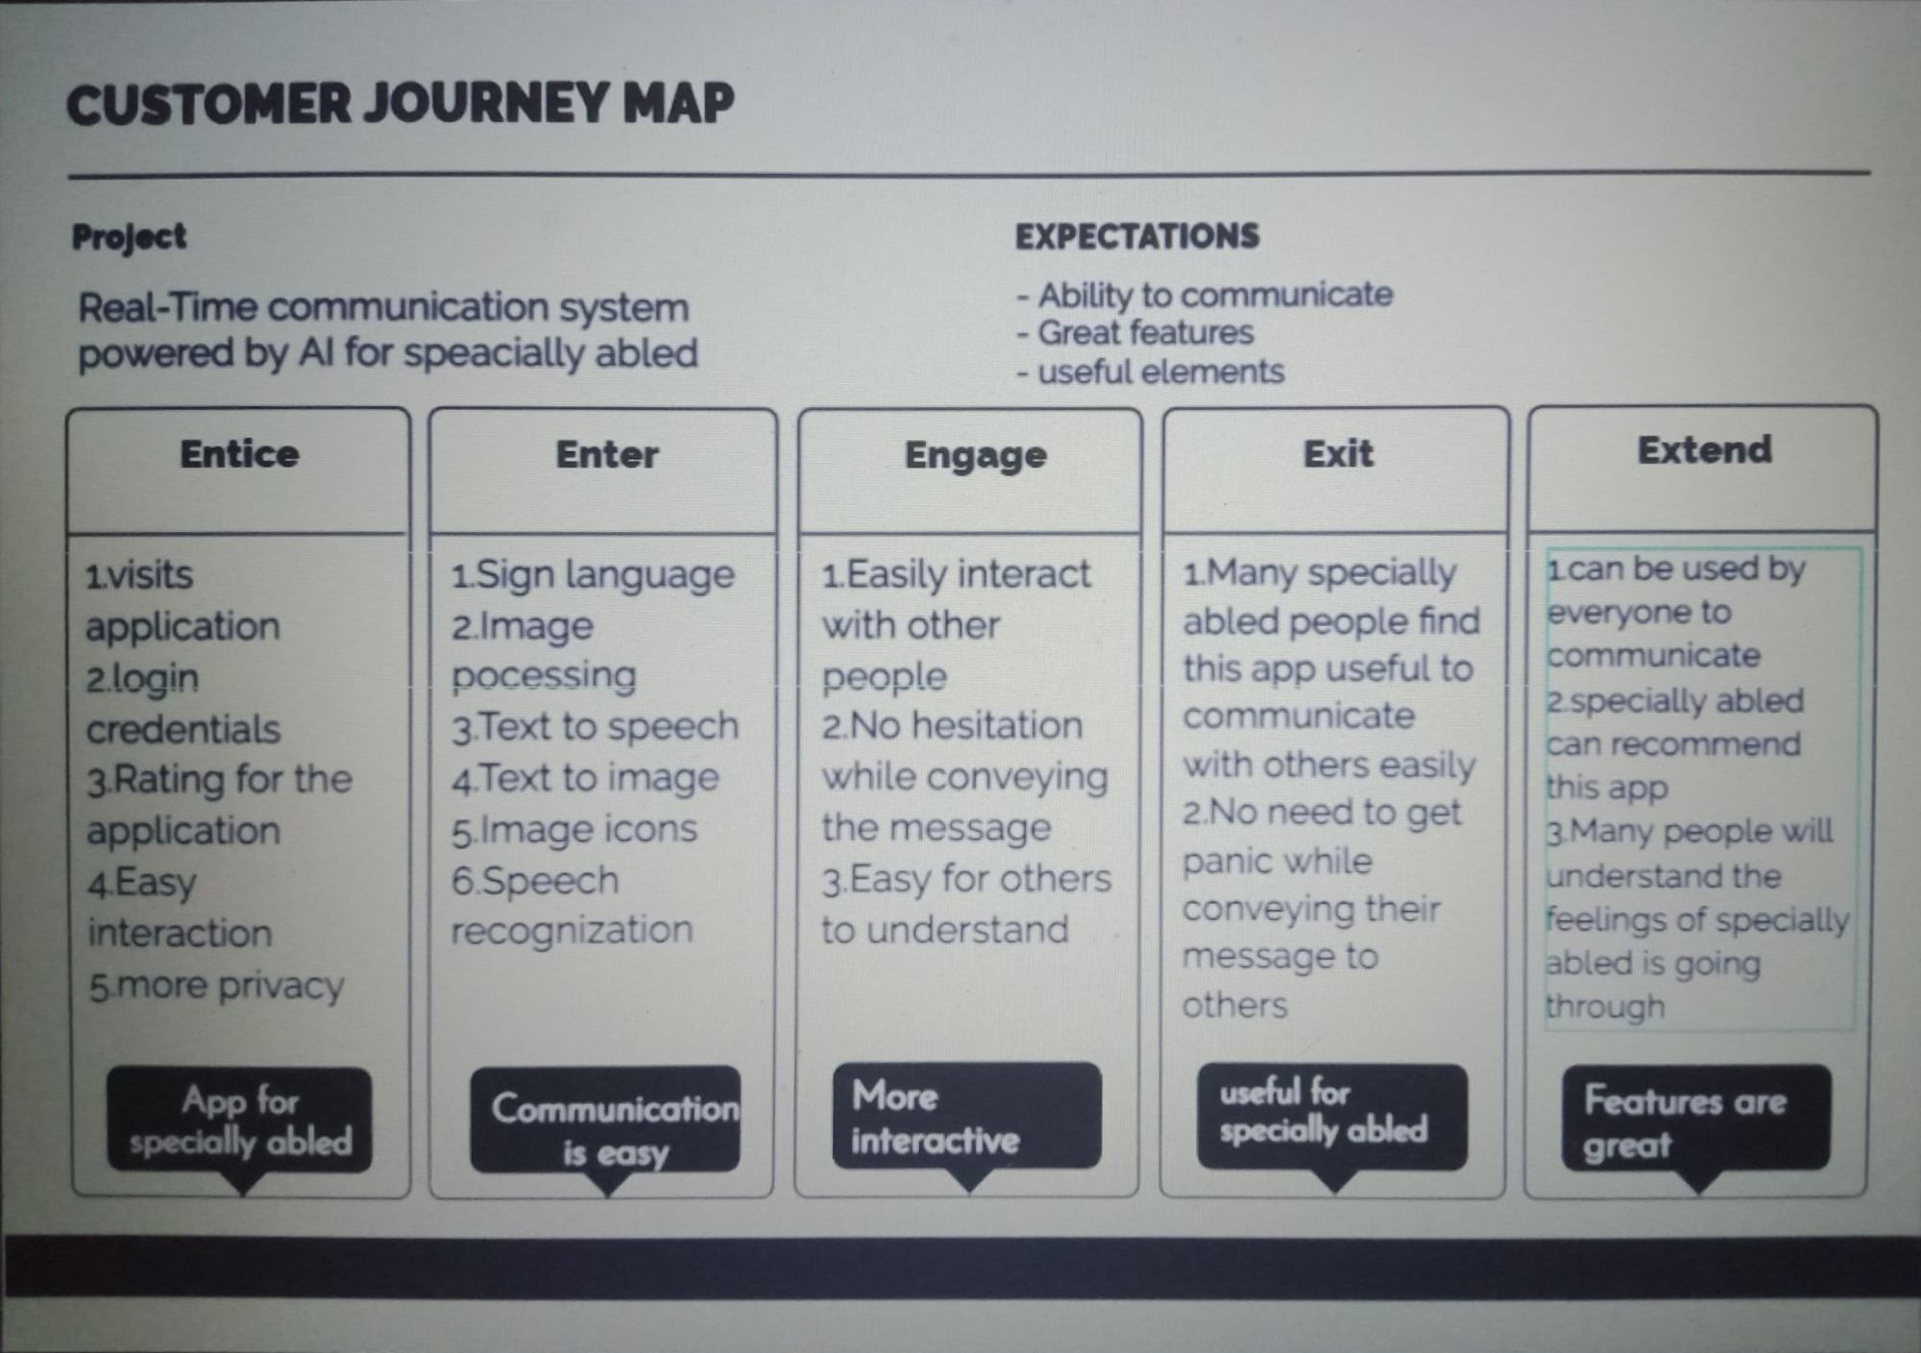

1